- Basic – 25 – Map Essentials
Directions: Label the locations listed – completed map should be KEPT and studied in preparation for the Map Essentials Test given within the first couple weeks of school.
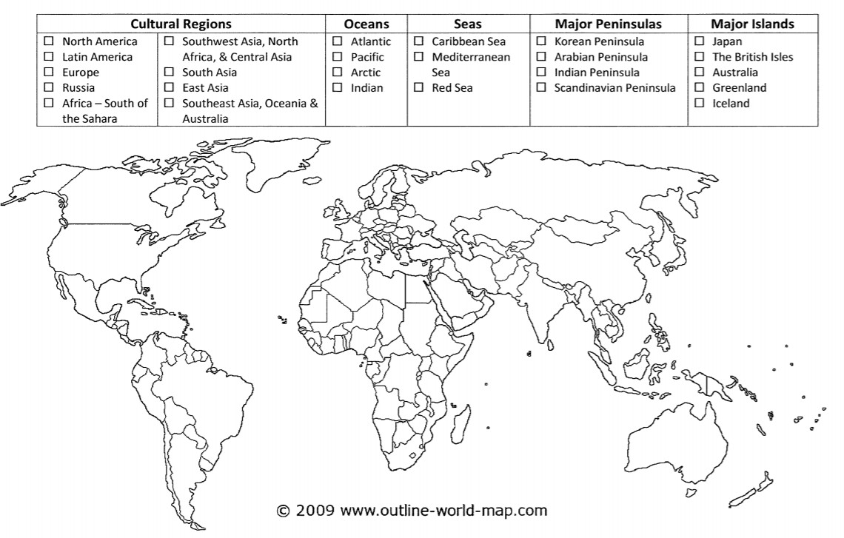

2. Physical – 25 – Map Essentials
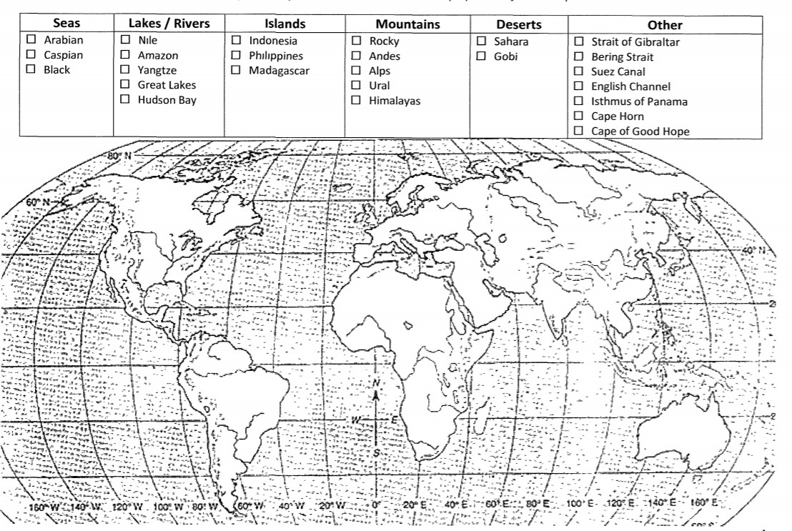
Directions: Label the locations listed – completed map should be KEPT and studied in preparation for the Map Essentials Test given within the first couple weeks of school.

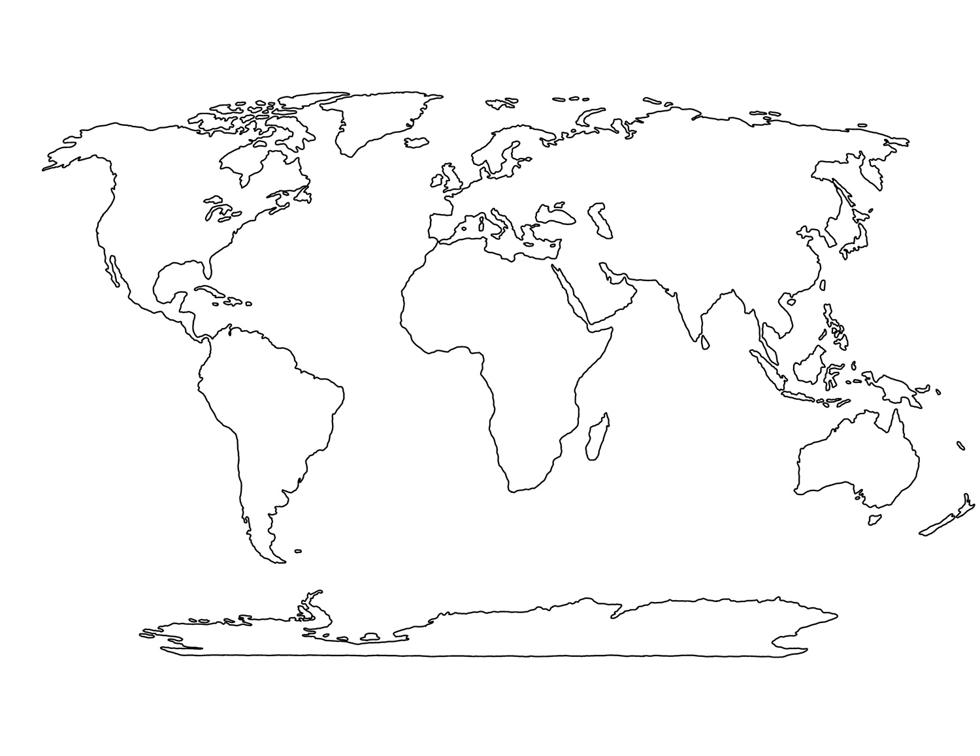

- Mapping Skills:
Directions: Using the above map (make multiple copies), create and label 3 maps. Each map should have a title, key and a compass rose. The colors are suggested but you may use your own. All labels should be in black pen.

Important things to remember when creating a map:
- Water is always blue (when needed)
- Land is never blue
- Use colored pencils, not crayons or markers
- Labels should go in the same direction
- Labels should be in black in

Map #1 Climate Zone Map
There are several climate zones around the world. Your map should be color coded and labeled (Use the legend to do this). Identify the following:

Tropical Wet – Dark Green Arid – Yellow
Humid Subtropical – Pink Tundra - White
Tropical Dry – Orange Mediterranean - Purple
Subarctic – Gray Highlands - Brown
Semiarid – Red Marine West Coast – Light Green or tan

Map #2 Population Density Map
Population density maps show how may people live in a specified area. For this map, you will look at persons per square mile. Make sure you are creating a population density map, NOT a population map. Your map should be color coded and labeled (use the legend to do this). Use the following:

# of people per square mile Color
- Yellow
1-24 Pink
25-129 Green
130-259 Orange
260-519 Red
520+ Purple

Map # 3 Elevation Map
Elevation maps show the height of the land above sea level in different areas of the world. Use color to show the height of the land. Your map should be color coded and labeled (use the legend to do this).

Height above sea level (in feet) Color
Below sea level Green
At sea level Yellow
1-499 feet above sea level Brown
500-999 feet above sea level Purple
1,000-1,999 feet above sea level Orange
2,000+ feet above sea level Red

- Landforms & Bodies of Water
Directions: Define and provide a picture of each landform and body of water listed.
If completed digitally, you can copy/paste/resize pictures to fit into the chart. If completed by hand, please attempt to provide neat/organized sketches. Color is not necessary but may be beneficial to illustrate landforms and bodies of water accurately.

Landforms Chart
1. Archipelago  Description:  Picture/Sketch: | 2. Canyon  Description:  Picture/Sketch: | 3. Cape  Description:  Picture/Sketch: | 4. Desert  Description:  Picture/Sketch:
5. Escarpment  Description:  Picture/Sketch: | 6. Fjord  Description:  Picture/Sketch: | 7. Mesa  Description:  Picture/Sketch: | 8. Mountain  Description:  Picture/Sketch:
9. Peninsula  Description:  Picture/Sketch: | 10. Plain  Description:  Picture/Sketch: | 11. Plateau  Description:  Picture/Sketch: | 12. Valley  Description:  Picture/Sketch:

Bodies of Water Chart
13. Aquifer  Description:  Picture/Sketch: | 14. Atoll  Description:  Picture/Sketch: | 15. Barrier Reef  Description:  Picture/Sketch: | 16. Bay  Description:  Picture/Sketch:
17. Channel  Description:  Picture/Sketch: | 18. Fringe Reef  Description:  Picture/Sketch: | 19. Glacier  Description:  Picture/Sketch: | 20. Gulf  Description:  Picture/Sketch:
21. Lake  Description:  Picture/Sketch: | 22. River  Description:  Picture/Sketch: | 23. River Delta  Description:  Picture/Sketch: | 24. Strait  Description:  Picture/Sketch:
25. Tributary
Description: Picture/Sketch:

- Mapping Skills
Directions: Answer the questions using the Mapping Visuals provided (see pages 7-12 of Primer Packet).

Basic Map Components Use Visual A for the following questions.
  - Write the map’s title.
  - How many picnic areas does the park have?
  - Name the two historical monuments south of the Gold Discovery Site.

  - Name the footpath you find at the grid coordinates F1.
  - What direction is St. John’s Church from the Olde Coloma Theatre?
  - What direction is St. John’s Church from the Schoolhouse?

Longitude and Latitude: Use Visual B and Visual C for the following questions.
  - Write the name of the parallel at 0˚ latitude.
  - Write the name of the meridian at 0˚ longitude.
  - Write the name of the parallel at 23.5˚N latitude.
  - Write the name of the parallel at 23.5˚S latitude.
  - Write the name of the parallel at 66.5˚N latitude.
  - Write the name of the parallel at 66.5˚S latitude.
  - Name the city located at 41˚N, 29˚E.
  - Name the city located at 19˚N, 73˚E.
  - Name the two (2) cities located north of the 15˚N latitude and east of the 105˚E longitude.

  - Name the two (2) cities located south of the 15˚S latitude and west of the 15˚E longitude.

Scale: Use Visual D for the following questions.
(Hint: pay close attention to the map features when answering the following questions)
  - What is the distance between Washington, D.C., and New Carrollton? miles
  - What is the distance between the Washington Convention Center and the National Portrait Gallery?
miles
  - What will you find approximately 0.75 miles west of the National Portrait Gallery?

  - What will you find approximately 10 miles east of Alexandria?
  - Which map will help you find your friend’s apartment on New York Avenue? (provide the full map title)

  - Which map will help you decide if you should walk or take a taxi to Washington, D.C., from Arlington? (provide the full map title)

Hemispheres, Continents and Oceans: Use Visual E for the following questions.
  - Name the two hemispheres the United States is located in.
  - Name the hemisphere Africa is located in.
  - What is the continent directly north of Africa?
  - What ocean touches the shores of Europe and South Africa?
  - Name the three continents the equator runs through.

  - Name the ocean that lies north of Europe.
  - Name the ocean that touches the shores of both Asia and South America. 30.Name the ocean that lies to the south of Asia.

Visual A

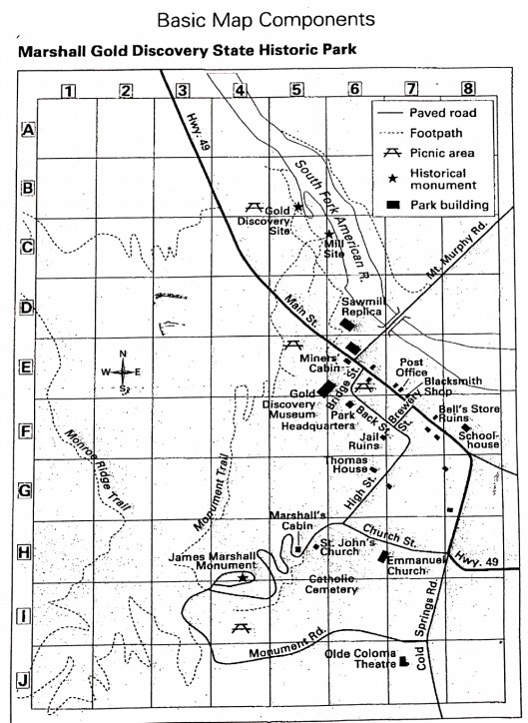

Visual B

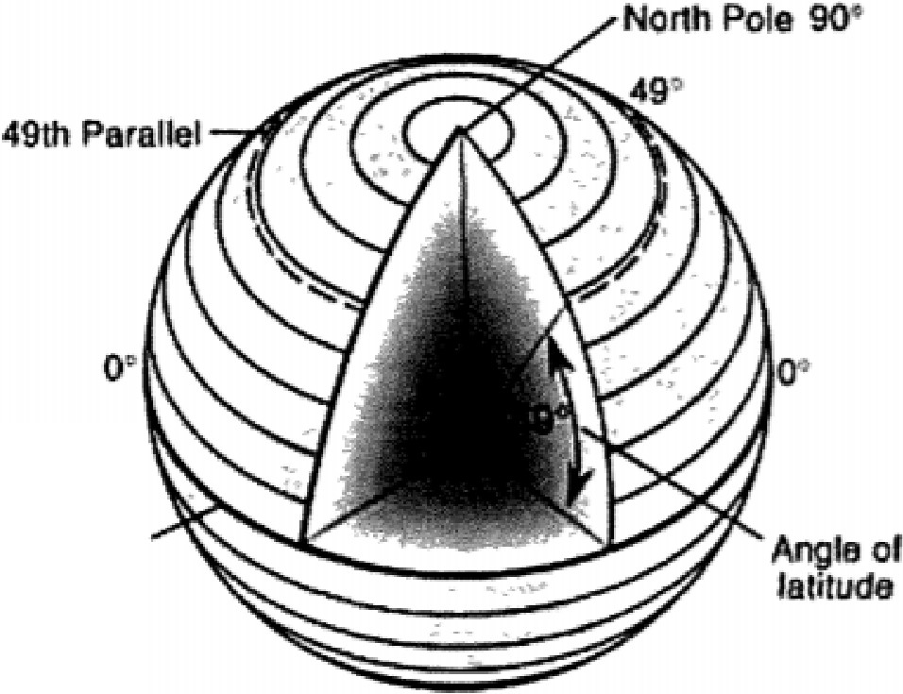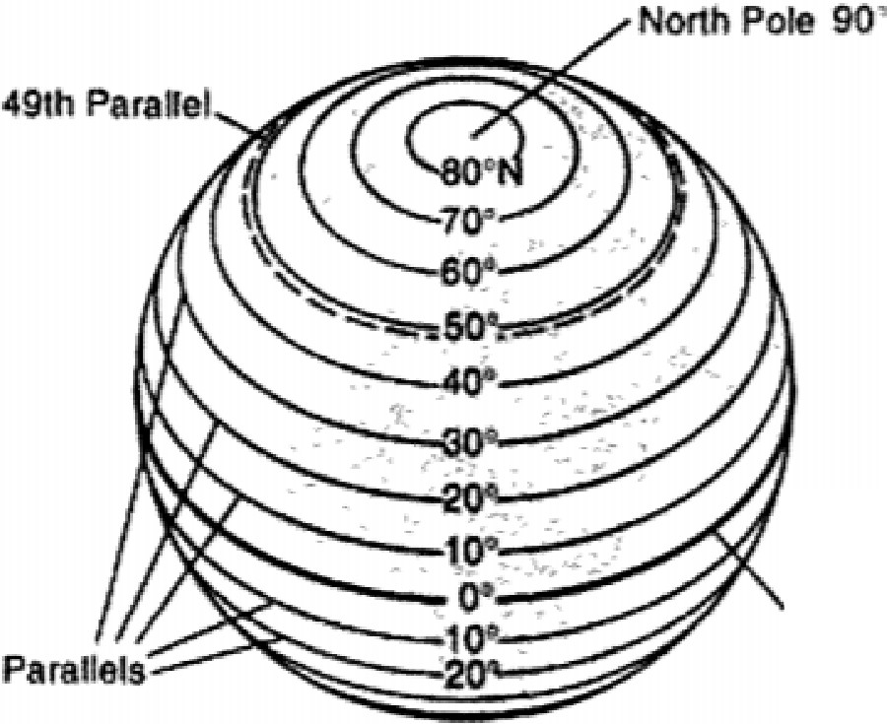
Equatorial
plane
Equatorial parallel

latitude is Measured from the Equator (O")
Latitude Lines Run

East.to West
(think: lat is flat)

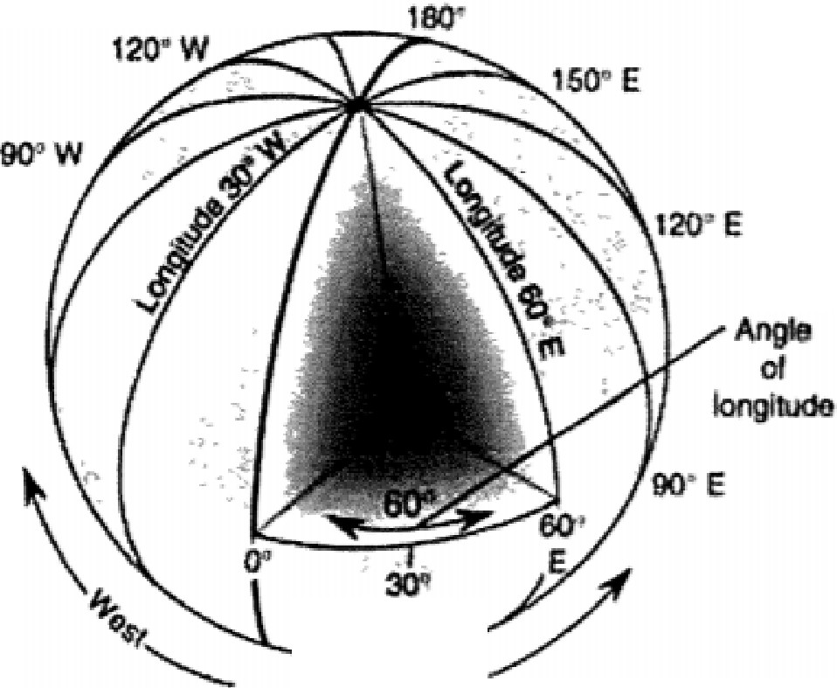150" W

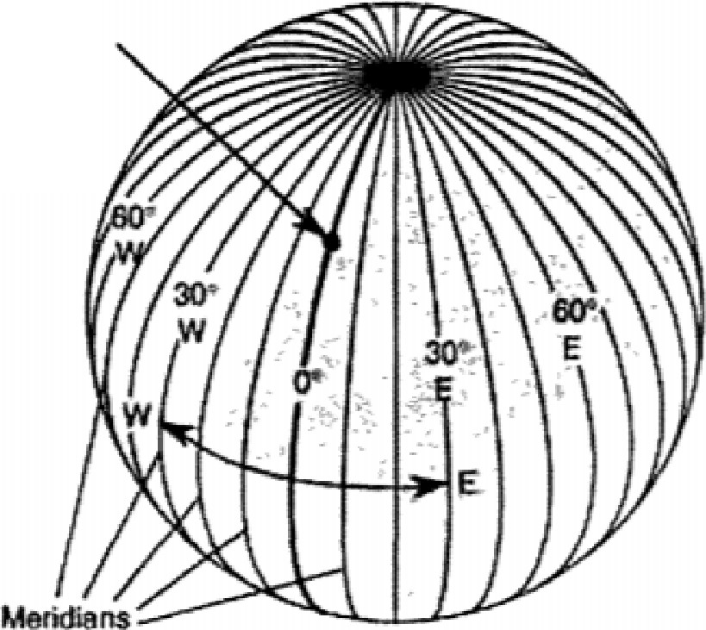
Greenwich, England
(prime meridian

WW

- . -
East

Longitude is measured from
the Prime Meridian (O")
Longitude lines Run

North to South
think. "go long: like you're throwing. football)

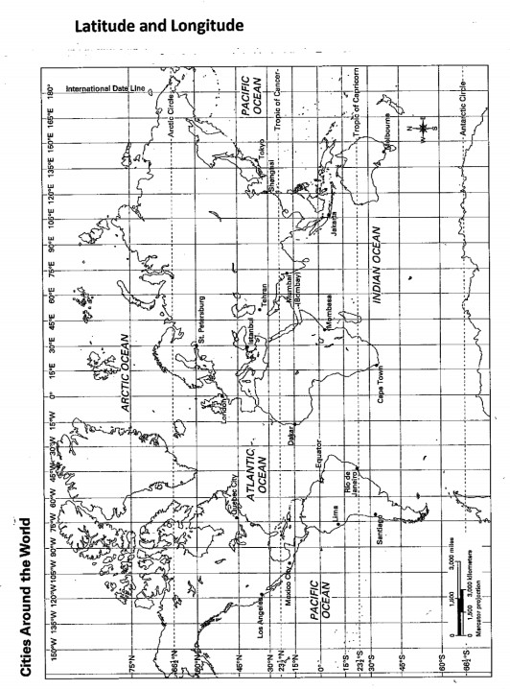
Visual C

Scale Visual D

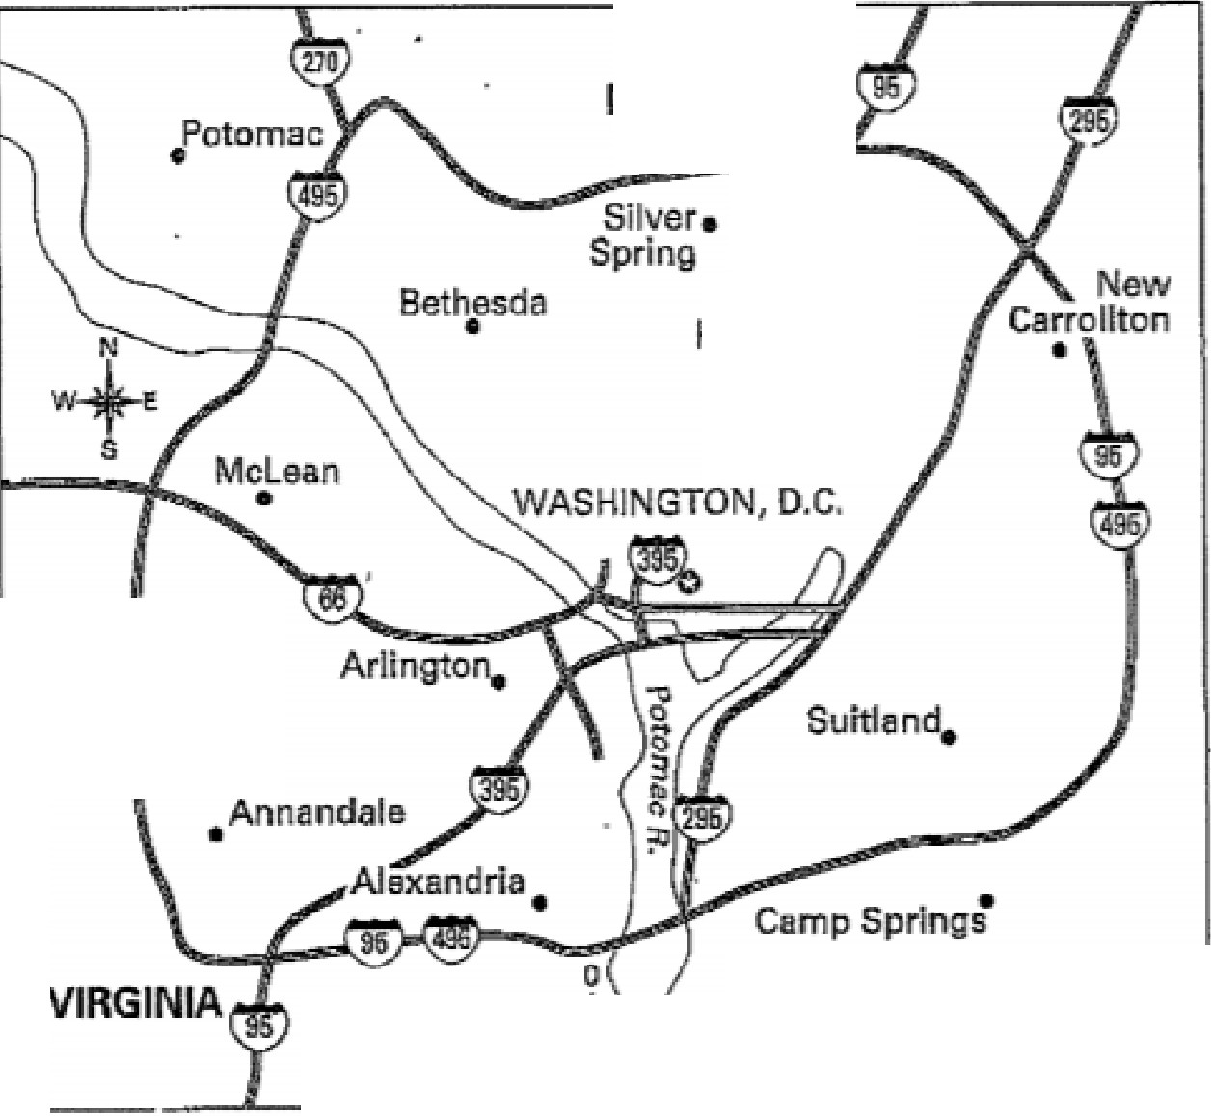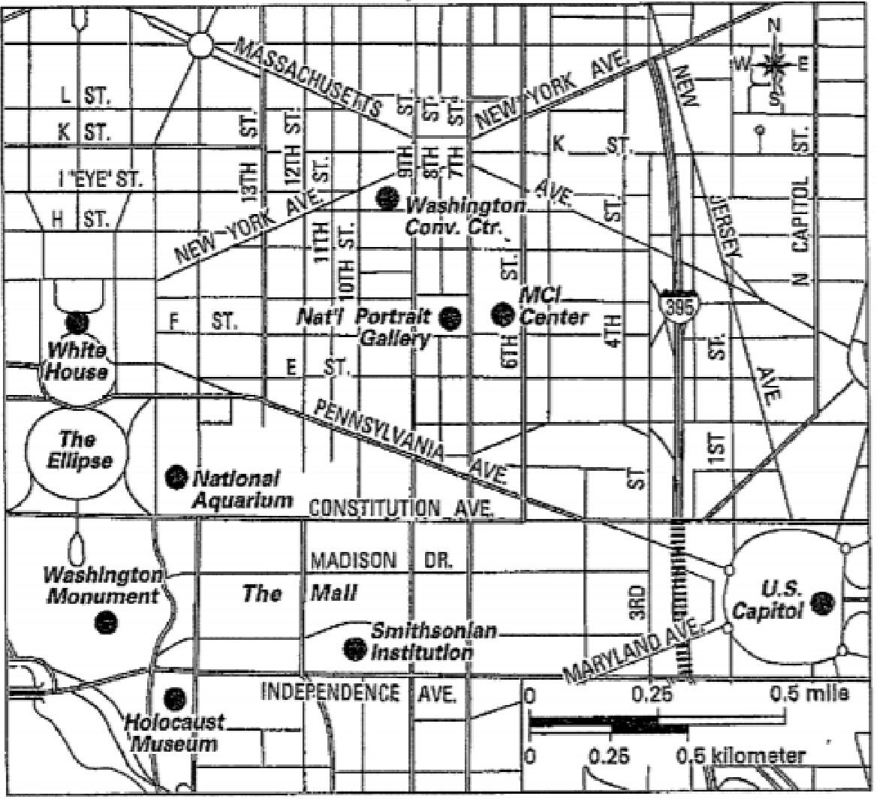
Washington, D.C., and Su1TOunding.Areas
MARYLAND
College
Park
Hyattsville•
. .
' 'Fails
Church
6i
10 miles

Downtown Washington, D.C.
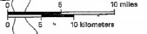

Hemispheres, Continents, and Oceans
visual E

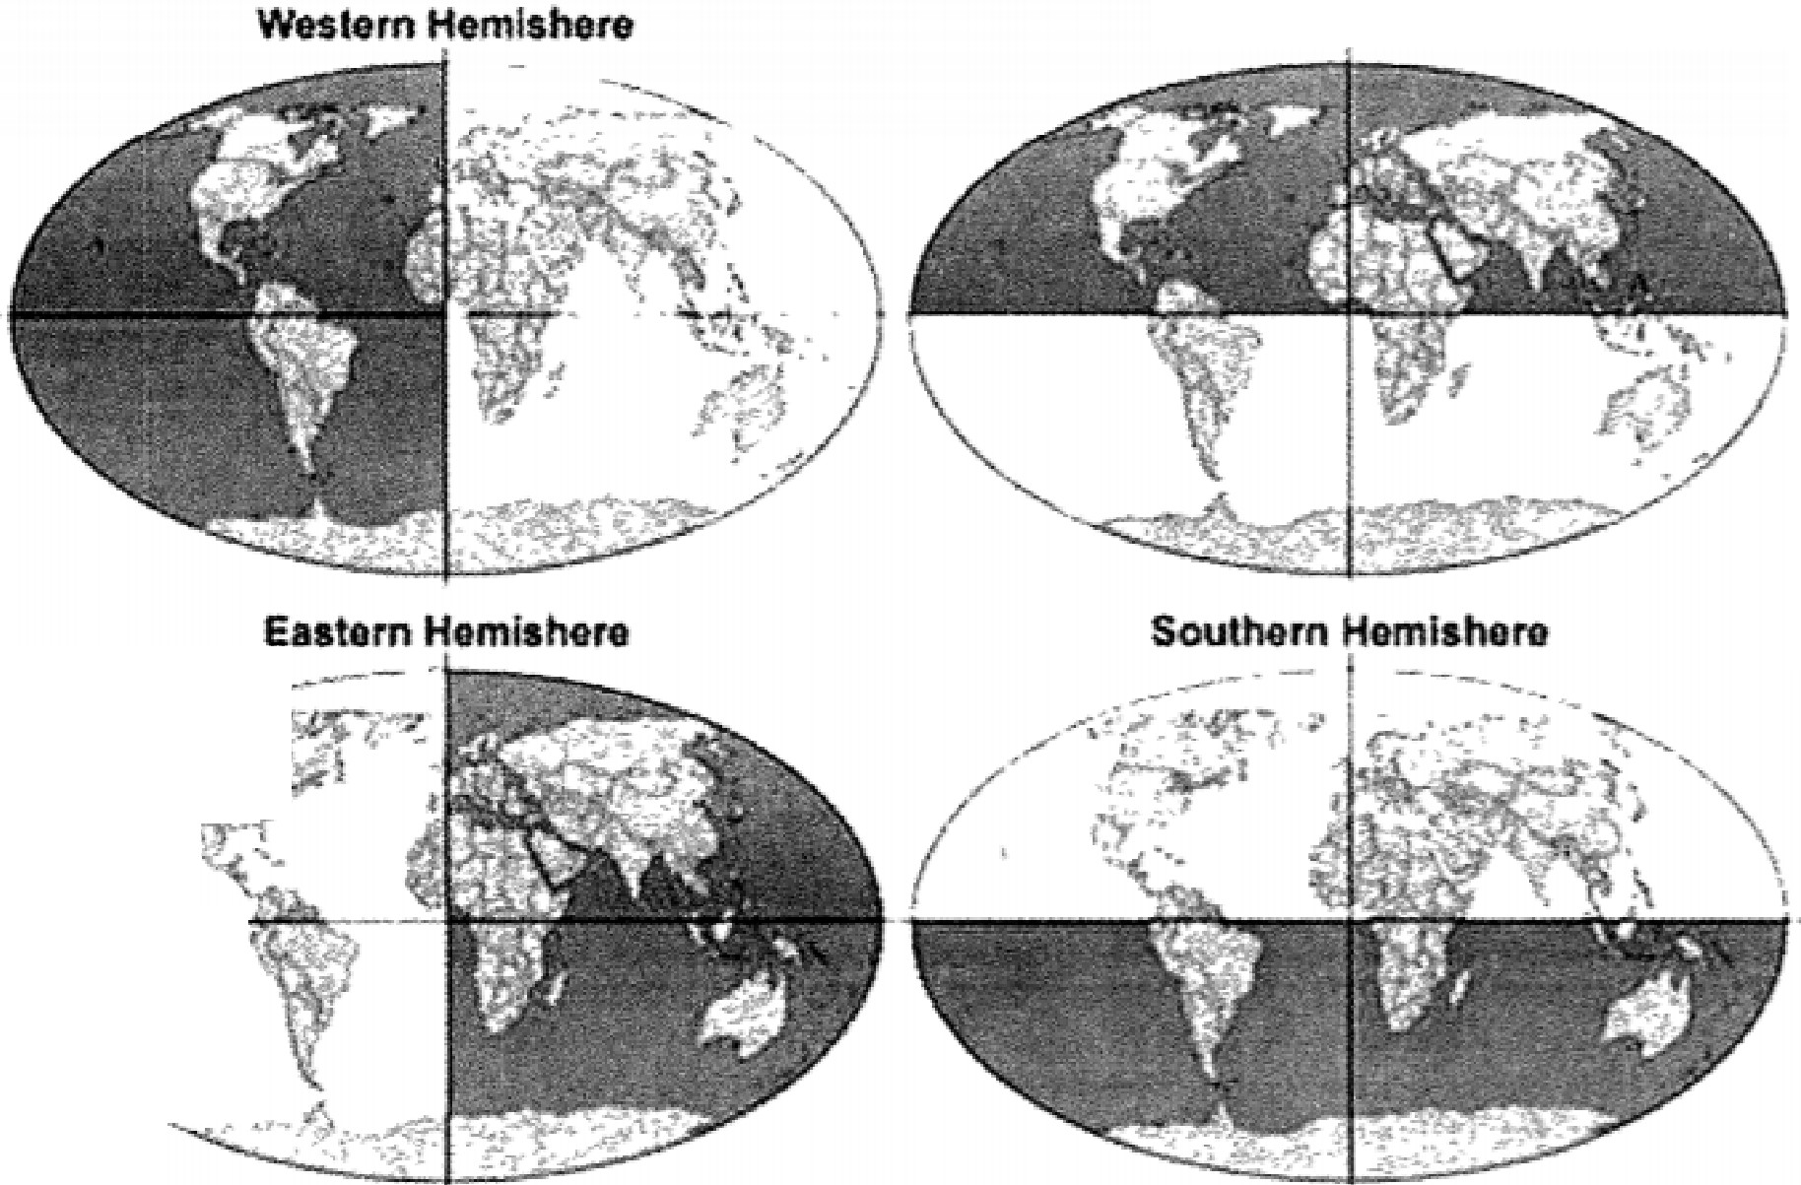I
Northern Hemisphere:
-·
. \
. ;:- .,
I- -- - - -<!,i, ,--
I
,. .

The World
